Instructions
Step 1: Insert your logo into the word document.
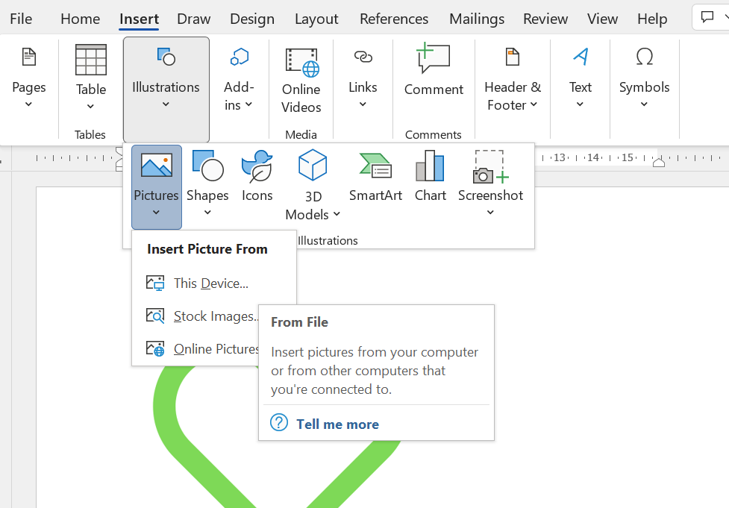
Insert - Illustrations – Pictures – This Device

Step 2: Set the Text Wrapping to Square
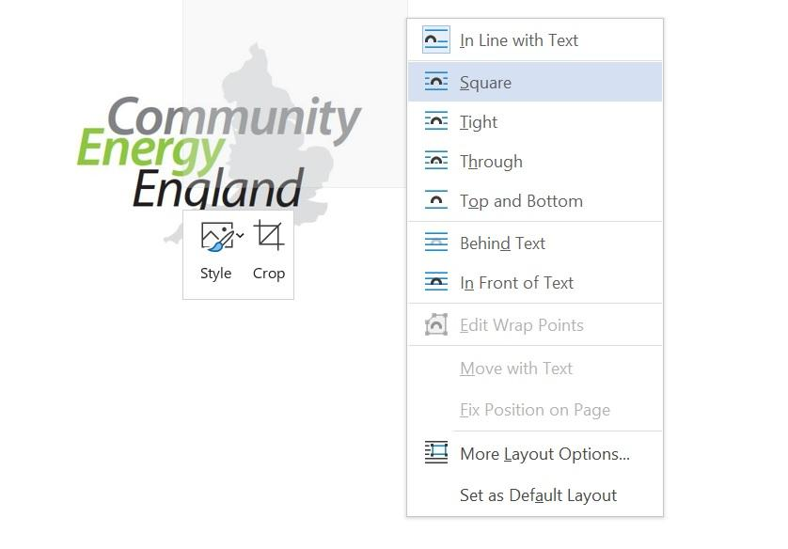
Left click on picture – Wrap Text - Square

Step 4: Set transparent background
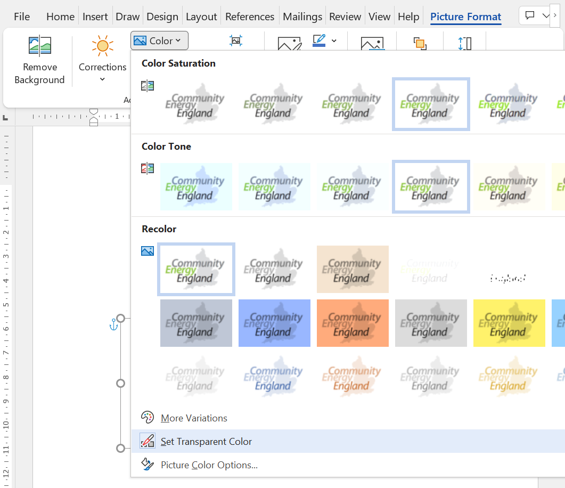
Select logo – Picture Format – Colour – Set Transparent Colour – Click on background

Step 5: Bring to front
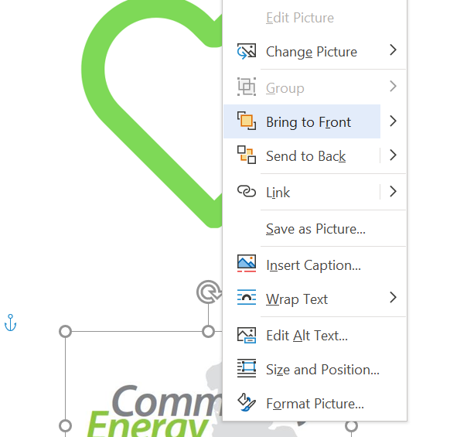
Right click on logo – Bring to Front

Step 6: Move and resize the logo to fill as much of the heart as possible

Now your green heart is complete! Print it off, stick it to some cardboard, cut it out and attach a safety pin to the back using some sticky tape.
Then post it to your MP with a letter explaining why you are contacting them, and request they tweet or post a photo tagging #communityenergy and @[yourtwitterhandle] so we can retweet. For a draft letter please click here. To make sure they receive it, email the letter to your MP to remind them to wear the heart.

