Community Energy  Get involved in your local solution to climate change    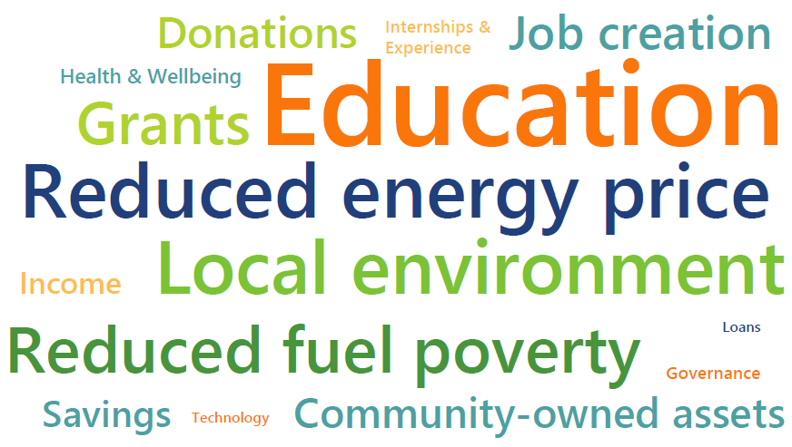  Community energy helps to decarbonise, democratise & decentralise the energy system. Local groups are installing community-owned solar, wind, hydro, heat and doing education, energy saving and fuel poverty work. At present, they generate enough power for 64,000 homes whilst creating a host of local benefits such as…  Find your local community energy organisation at www.bit.ly/CEgroupmap.  Volunteer and/or invest to help community energy grow the green economy in your local area. |  | Community Energy  Get involved in your local solution to climate change  Community energy helps to decarbonise, democratise & decentralise the energy system. Local groups are installing community-owned solar, wind, hydro, heat and doing education, energy saving and fuel poverty work. At present, they generate enough power for 64,000 homes whilst creating a host of local benefits such as…  Find your local community energy organisation at www.bit.ly/CEgroupmap.  Volunteer and/or invest to help community energy grow the green economy in your local area.
Community Energy  Get involved in your local solution to climate change  Community energy helps to decarbonise, democratise & decentralise the energy system. Local groups are installing community-owned solar, wind, hydro, heat and doing education, energy saving and fuel poverty work. At present, they generate enough power for 64,000 homes whilst creating a host of local benefits such as…  Find your local community energy organisation at www.bit.ly/CEgroupmap.  Volunteer and/or invest to help community energy grow the green economy in your local area. |  | Community Energy  Get involved in your local solution to climate change  Community energy helps to decarbonise, democratise & decentralise the energy system. Local groups are installing community-owned solar, wind, hydro, heat and doing education, energy saving and fuel poverty work. At present, they generate enough power for 64,000 homes whilst creating a host of local benefits such as…  Find your local community energy organisation at www.bit.ly/CEgroupmap.  Volunteer and/or invest to help community energy grow the green economy in your local area.

